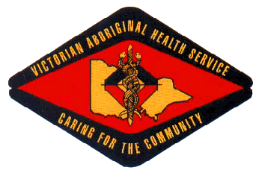

VICTORIAN ABORIGINAL HEALTH SERVICE – COMPLAINT FORM

Use this form to make a complaint. Please provide as much information as you can, so we can help you.

1. Your details
Title: | First name: |  |  |  |  |  | Last name:
Middle name: |  |  |  |  | Gender: Female Male |  |  |  |  | Date of birth:
Postal address:
Suburb/town: |  |  | State: |  |  |  |  | Postcode:
Daytime telephone: |  |  | Mobile: |  |  |  |  | Email:
My preferred method of contact is: |  | Telephone |  | Email |  | Letter |  |  | Other  Details:
Do you identify as Aboriginal and/or Torres Strait Islander? No Aboriginal Torres Strait Islander Both
Your preferred language: |  |  |  |  |  |  | Your country of birth:
Do you have any special needs? No Yes  Please specify:
Are you making this complaint on behalf of someone else? No Skip to 3. Yes  Go to 2.

2. Details of the person you are complaining on behalf of
Title: | First name: |  |  |  | Last name:
Middle name: |  |  | Gender: Female Male |  |  |  | Date of birth:
Postal address:
Suburb/town: |  | State: |  |  |  | Postcode:
Daytime telephone: |  | Mobile: |  |  |  | Email:
What is the person’s relationship to you? Next-of-kin Other |  |  |  | Has the person asked you to make this complaint? No Yes
Is the person a child? No Yes
Does the person identify as Aboriginal and/or Torres Strait Islander? No Aboriginal Torres Strait Islander Both

3. Who is this complaint about? (Please include as much information as possible).
First name: |  | Surname:
Type of health service provider (e.g. doctor, dietician, health worker):
VAHS Employee: Yes |  |  | No:
If more than one person involved: | First Name: |  |  | Surname:
Type of health service provider (e.g doctor, dietician, health worker):

4. How have you tried to resolve this complaint?
Have you already complained to VAHS?
No
Yes  Please provide details of person/s you have already spoken to and date
Date the health service was provided:

5. Your complaint
 Tell us:  What happened  Who was involved  When and where it happened  When you become aware of the problem  The main issues you are concerned with.
 Attach another page if you need more space. Attach copies of any supporting information—letters, reports, photos, invoices.

What would you like to happen to resolve your complaint?
E.g acknowledgement / apology /disciplinary action / policy/process change Details:

7. Send us your complaint form
 Mail: 186 Nicholson St Fitzroy Vic 3072  Fax: (03) 9403 3333  Email: complaints@vahs.org.au
We will contact you within 7 days of receiving your complaint form. (Note: emails may appear in junk mail, depending on your settings.) 

