JOB VACANCY – VICTORIAN ABORIGINAL HEALTH SERVICE 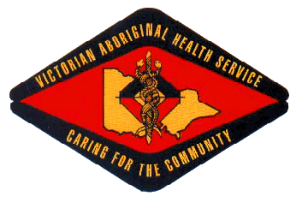

Position Title: Koori Engagement Officer – Parenting Program
Location: Preston (Melbourne)
Employment Status: Fixed Term – June 2019
Reports To: Koori Kids and Adolescent Social & Emotional Wellbeing Team Leader

About the Organisation

The Victorian Aboriginal Health Service (VAHS) was established in 1973 to address the specific medical needs of Victorian indigenous communities. The organisation has expanded steadily over past 40 years to provide a comprehensive range of medical, dental and social services for our community.

As well as providing a variety of medical services, VAHS is committed to supporting the well-being of the community through contributions to community events and activities. VAHS is also committed to assisting research into the ongoing needs of the community.

About the Opportunity

The Koori Engagement Officer is responsible for engaging parents, carers, families and staff and supporting the delivery of targeted and culturally responsive parenting programs. Working with the Parenting Program Coordinator, this position is integral to the design, planning and delivery of a range of group and individual parenting programs.

Key Selection Criteria

To be considered for this role you must have the following;

- A well-developed understanding of and sensitivity to Aboriginal cultural values and approaches to mental health, and social and emotional wellbeing.
- A general understanding of and interest in Aboriginal children’s health and development and appreciation of the needs and concerns of children and their families.
- A demonstrated understanding of and interest in attachment and trauma and the impact of these on children’s development, health and wellbeing.
- Strong community networks and relationships.
- Sound organisation and time management skills.
- Good verbal and written communication skills and the ability to communicate effectively with young children, their parents, carers, families, the Aboriginal Community, colleagues and other health professionals.
- Good computer skills and an understanding of data collection.
- The demonstrated ability to work effectively as part of a multi-disciplinary team.
- Knowledge of and demonstrated understanding of and commitment to the principles of equity, diversity and occupational health and safety.

Qualifications, Licenses and Registrations

- Certificate 3 in Aboriginal Health Work or equivalent and/or relevant work experience.
- Current Victorian Driver’s License
- Current Working with Children Check & National Police Check

How to Apply

Applications can be submitted to:
Employment @vahs.org.au before Wednesday 5pm, 7th November 2018. Request for position description can be made via employment @vahs.org.au.

This position is not available to persons not of Aboriginal and / or Torres Strait Islander descent. (permitted under The Victorian Equal Opportunity Act 2010 s12 “A person may take a special measure for the purpose of promoting or realizing substantive equality for members of a group with a particular attribute’”)

Please note that due to a high volume of applicants only shortlisted candidates will be contacted.

