JOB VACANCY – VICTORIAN ABORIGINAL HEALTH SERVICE 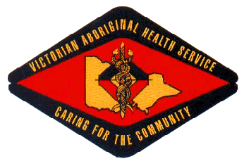

Position Title: Programs Coordinator
Location: Preston (Melbourne)
Employment Status: Full-time 12 months Fixed-Term
Reports To: Team Leader, Adult SEWB Program, Family Counselling

About the Organisation

The Victorian Aboriginal Health Service (VAHS) was established in 1973 to address the specific medical needs of Victorian indigenous communities. The organisation has expanded steadily over past 40 years to provide a comprehensive range of medical, dental and social services for our community.

As well as providing a variety of medical services, VAHS is committed to supporting the well-being of the community through contributions to community events and activities. VAHS is also committed to assisting research into the ongoing needs of the community.

POSITION OUTLINE

The Programs Coordinator role involves proactive engagement, development and establishment of meaningful relationships and partnership arrangements with a range of stakeholders to support increased access to locally available AOD/Mental Health/SEWB/Suicide Prevention services for the Aboriginal community in the North West catchment.
You will be responsible for providing leadership and developing strategic direction and co-ordination with regards to establishing new and innovative services that will cover the NW metropolitan region.
The Programs Coordinator will support the development of a project team to deliver services to Aboriginal individuals and families affected and seeking support to address impacts and recovery options related to alcohol and other drug issues, mental health and social and emotional wellbeing issues including suicide prevention activities.

Key Selection Criteria

To be considered for this role you must have the following;

- Understanding of and Commitment to the Aboriginal community.
- A demonstrated appreciation of the broad spectrum of trauma informed care and social and emotional well-being issues and associated impacts, support needs and recovery strategies.
- Experience in a health service, environment or related facility is an advantage.
- Proven leadership and the ability to supervise staff.
- Demonstrated skills in case management.
- Good organisation and time management skills.
- Proven ability to organise and manage a multi skilled team
- Excelled written and verbal communication skills.
- Knowledge of and demonstrated understanding of and commitment to the principles of equity, diversity and occupational health and safety.

Qualifications, Licenses and Registrations

- Qualifications in Health, Mental Health, Social Work, Program Management or related discipline
- Qualifications in Aboriginal Health or similar
- Current Victorian Driver’s License
- National Police Check
- Current Working with Children Check

How to Apply

Applications can be submitted to:

Employment @vahs.org.au by Tuesday 5pm, 23rd October 2018. Request for position description can be made via employment @vahs.org.au.

