JOB VACANCY – VICTORIAN ABORIGINAL HEALTH SERVICE 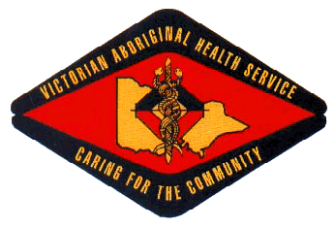

Position Title: Sexual Health & BBV Nurse
Location: Fitzroy (Melbourne)
Employment Status: Fixed Term – February 2019
Reports To: Senior Medical Officer

About the Organisation

The Victorian Aboriginal Health Service (VAHS) was established in 1973 to address the specific medical needs of Victorian indigenous communities. The organisation has expanded steadily over past 40 years to provide a comprehensive range of medical, dental and social services for our community.

As well as providing a variety of medical services, VAHS is committed to supporting the well-being of the community through contributions to community events and activities. VAHS is also committed to assisting research into the ongoing needs of the community.

About the Opportunity

The Sexual Health Nurse will support Medical Practitioners and Aboriginal Health Workers on matters relating to BBV / STI. The emphasis of the role is on clinical practices throughout the VAHS as well as Health Promotion.

Key Selection Criteria

To be considered for this role you must have the following;

- An understanding and commitment to Aboriginal Culture and ability to work with an Aboriginal Health Worker.
- A demonstrated understanding of BBV / STI and their effects on aboriginal people, their families and the community.
- Demonstrated ability to educate and train Aboriginal Health Workers and Health Professionals.
- Demonstrated experience in the developing, implementing and evaluation of health promotion programs.
- Good verbal and written communication skills and the ability to communicate effectively with patients, their carers and the Aboriginal Community
- Computer literate. Demonstrated ability to provide flexible responses to client needs.
- The demonstrated ability to work effectively as part of a multi skilled team.
- Demonstrated high level of energy, enthusiasm, reliability, resilience and flexibility
- Knowledge of and demonstrated understanding of and commitment to the principles of equity, diversity and occupational health and safety.

Qualifications, Licenses and Registrations

- A Registered General Nurse in the State of Victoria’ with relevant post graduate qualifications
- Accredited or the ability to become accredited in Sexual and Reproductive Health Part 1 and 2 (Pap Smear Provider) and or an equivalent Men’s Sexual Health qualifications or the ability to undertake training in either area mentioned.
- Accredited or the ability to become accredited as a person of the prescribed class in HIV HCV Pre and Post Test Counselling
- Current Victorian Driver’s License
- Current Working with Children Check & National Police Check

How to Apply

Applications can be submitted to:
Employment @vahs.org.au before Monday 9am, 22nd October 2018. Request for position description can be made via employment @vahs.org.au.

Please note that due to a high volume of applicants only shortlisted candidates will be contacted.

