JOB VACANCY – VICTORIAN ABORIGINAL HEALTH SERVICE 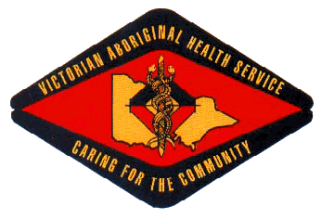

Position Title: Speech Therapist
Location: Fitzroy and Preston (Melbourne)
Employment Status: Full-time 12 months Fixed-Term
Reports To: Women and Children’s Manager

About the Organisation

The Victorian Aboriginal Health Service (VAHS) was established in 1973 to address the specific medical needs of Victorian indigenous communities. The organisation has expanded steadily over past 40 years to provide a comprehensive range of medical, dental and social services for our community.

As well as providing a variety of medical services, VAHS is committed to supporting the well-being of the community through contributions to community events and activities. VAHS is also committed to assisting research into the ongoing needs of the community.

POSITION OUTLINE

The Victorian Aboriginal Health Service is looking to employ a Speech Pathologist to join the Women & Children’s Unit.

The role is responsible for the assessment and management of speech and language disorders in children and adolescents, through primary consultations and provision of secondary consultations to VAHS clinicians on appropriate management of children and young people.

Key Selection Criteria

To be considered for this role you must have the following;
- Demonstrated appreciation of, and sensitivity to Aboriginal cultural values and approaches to mental health, and social and emotional wellbeing.
- High level of interpersonal skill and demonstrated ability to successfully engage with clients, their carers, extended family members, members of the general community and other involved professionals.
- Extensive experience in working with children and families with complex needs.
- Demonstrated understanding of attachment and trauma and the impact of these on children’s development, health and wellbeing.
- Demonstrated experience in assessing and managing speech and language and swallowing disorders in infants, children & adolescents and supporting their parents/carers.
- Demonstrated experience and capacity to assess the general developmental functioning of infants, young children and adolescents and their communication function in that context.
- Ability to supervise, debrief, and work closely with Aboriginal Health Workers and receive and incorporate cultural knowledge into practice.
- A professional standard of report writing, and verbal and written skills.
- The demonstrated ability to work effectively as part of a multi-disciplinary team.
- Knowledge of and demonstrated understanding of and commitment to the principles of equity, diversity and occupational health and safety.

Qualifications, Licenses and Registrations

- Qualification and registration as a Speech Pathologist with Speech Pathology Australia or the Australian Health Practitioner Regulatory Authority (AHPRA) where relevant.
- Current eligibility for a Healthcare Provider Identifier under Medicare.
- Current Victorian Driver’s License
- National Police Check
- Current Working with Children Check

How to Apply

Applications can be submitted to:

Employment @vahs.org.au by Monday 9am, 22nd October 2018. Request for position description can be made via employment @vahs.org.au.

